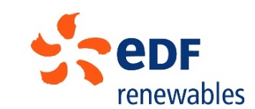
EDF Renewables Corriemoillie Wind Farm Community Benefit Fund
Year 7, 16th December 2022 – 15th December 2023

The Year at a Glance
- 453 grants (£610k) awarded since Fund launch

- 79 awards (£100k) made in Year 7

- 55 bursaries (£49k) awarded

- 49% bursaries in high priority sectors

- 97% of 2023 EDF donation distributed

Highlights
Year 7 of the EDF Renewables Corriemoillie Wind Farm Community Benefit Fund has supported 23 diverse community projects throughout the fund area to the value of £49,443. In addition, 55 individual residents have been awarded bursaries to help them access education and training courses (total awards of £48,854), and one local business has received an award for training in renewable heating installation (£2,500).

The total figure awarded represents 97% of the £103,600 community benefit funding provided by EDF Renewables for the year.

A diverse array of community projects have been supported – from community archaeology projects to bike trails, to support for a community zero waste shop. Case studies in this report highlight the range of activity which Corriemoillie funding has supported in the past year.

Community awards ranged in scale from £600 to deliver interactive story and activity sessions for pre-school children in Contin, to improve literacy, parenting and bring families together, to £5,320 to contribute to cost of residential outdoor activity trip for all senior pupils at Marybank and Strathconon Primary Schools to develop new skills, confidence and connections between children from different areas.

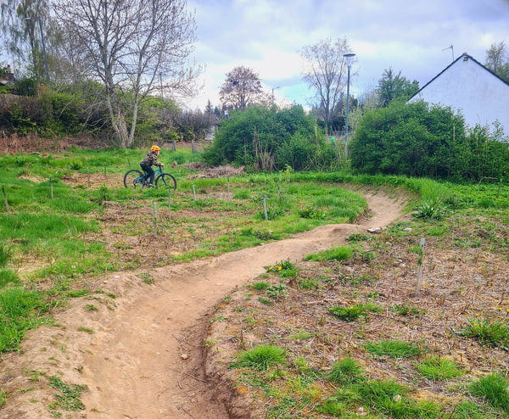
Strathpeffer Bike Zone

The maximum bursary award is for £1,500 for renewable and STEM related training and several awards were made at this level for a range of courses such as degrees in engineering, and electrician and construction modern apprenticeships. The smallest bursary was £200 to fund fees for Paddlesports Touring Leader Award. There continues to be a year-on-year increase in STEM courses supported with 49% of all bursary awards in this category in 2023 (up from 42% in the previous year).

Foundation Scotland continues to support three community panels in Contin, Strathpeffer and in Marybank, Scatwell & Strathconon to distribute their own sub funds, and has also administered the area-wide Education & Training Fund with a panel of residents drawn from the area. . Across all four sub-funds, X28 Panel members bring local knowledge and expertise and continue to give their time generously to help direct fund strategy and make grant decisions, contributing to the resilience and wellbeing of their communities.

This report outlines the year’s activity, describing how the funds are making a difference in each area. A summary of all awards and more detailed case studies, along with financial statements and governance information can be found in each section of this report.

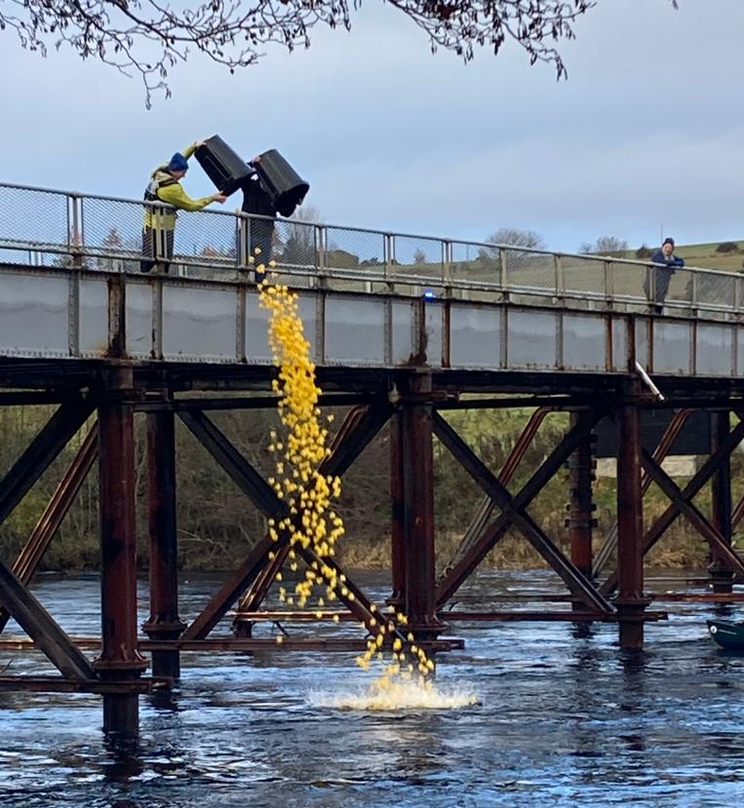
Marybank fundraising – launching the duck race!

Appendices cover background to the fund, overall financial statement and fund promotion.

Contents

1. EDF Renewables Corriemoillie Wind Farm Education & Training Fund 4
2 EDF Renewables Corriemoillie Wind Farm Community Benefit Fund - Contin 9
3. EDF Renewables Corriemoillie Wind Farm Community Benefit Fund - Strathpeffer 15
4. EDF Renewables Corriemoillie Wind Farm Community Benefit Fund – Marybank, Scatwell & Strathconon 20
5. EDF Renewables Corriemoillie Wind Farm Community Benefit Fund - Lochbroom 25
Appendix 1 - Education & Training Fund Award Summary 27
Appendix 2 - Background to the Fund 32
Appendix 3 – Education & Training Fund Framework 33
Appendix 4 - Financial Statement 34
Appendix 5 – Fund Promotion 35

EDF Renewables Corriemoillie Wind Farm Education & Training Fund

1.1 Making a Difference

During the first seven years of the Fund, 324 bursary awards have been made to individuals in the fund area. 61 of these were repeat awards, therefore 261 individuals have been supported. Monitoring feedback suggests that support for young under graduates has been particularly appreciated in the current climate of rising bills for rent, food and energy.
The fund also supports a smaller number of diverse projects relating to businesses and third sector organisations, and the following case study highlights one of the interesting and innovative projects which have been made possible with the Corriemoillie funds involving hospitality skills training to create a pilot staff bank in Ullapool.

Case Study:
Training Innovation in Ullapool

Ullapool Community Trust is a not for profit anchor organisation which delivers projects and supports groups in the Ullapool area. In 2022 UCT received an award of £3,000 for an innovative pilot project to deliver accredited hospitality skills training to local residents and creating a bank of hospitality staff for the area.

The aim of the project was to help address a staffing crisis for the local hospitality sector by creating a pool of trained workers already qualified in areas such as food hygiene, customer services, health and safety and first aid.

The scheme allows residents to earn income despite constraints they may have such as caring duties, other jobs that do not have regular hours or needing to keep flexible schedules. By using local residents, the issue of accommodation is also solved. For employers it means there is a willing group of local people happy to step in at short notice.

For pool employees, it’s proving to bring several benefits: helping people to feel part of the community, combatting isolation, keeping active, offering varied experiences, earning extra income, gaining confidence to (re)enter the world of work and learning many transferable skills.

The project idea was developed by UCT’s Employment and Training Working Group through survey and consultation with businesses and residents. The Corriemoillie panel was keen to support it with the caveat that businesses involved signed up to a code of conduct ensuring minimum standards and support would be in place.

The pilot trial ran throughout 2023.

Ullapool Community Trust’s Project coordinator said: “To have the support of the EDF Corriemoillie Fund was invaluable because it meant that we knew we could offer training to those people who wanted to work but needed essential qualifications. Overall, it would also mean that whether or not the pilot trial was deemed a success and worth continuing, this funding would ensure that we would be adding to the pool of trained people to the benefit of the whole community.

We were very lucky in that all the businesses who joined the pilot trial were very supportive of all staff members, offering on-site training and encouragement. Nevertheless, participants were glad to be able to brush up or take introductory courses in food hygiene, health and safety at work, fire safety awareness, first aid and mental health first aid. This last course has been on the wish list of many local employers, particularly in the hospitality sector, where stress levels can at times run high.”

The staff bank scheme is basically a virtual noticeboard - a WhatsApp group. UCT gets no income and neither does it have any employer obligations. All contracts, terms and pay are directly between employees and the business concerned. However, UCT does ensure that everyone joining reads the ground rules on permissions, privacy and courtesy and two codes of conduct: one for employers and one for employees.

While Pool staff can help to fill in gaps and take the pressure off when needed, it is important to note that the scheme is not a substitute for employers recruiting and retaining long-term staff with good pay, conditions, and professional development.

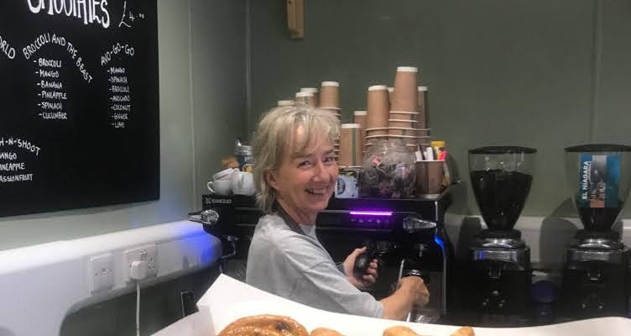

So far, people have worked for a few hours to a whole evening and whole days if they wanted to. They usually respond within a few hours to notices placed by employers, which have ranged from wanting regular cover during upcoming busy periods to short-term notice of one-off shifts to help permanent/longer-term staff, or to providing additional cover for special events. Training has been delivered locally, based on needs and has helped to upskill residents including school leavers.

The pilot has received positive feedback from employers and employees and is delivering real benefit to the local community. There is potential for the scheme to expand and cover other areas of work, though that might require more functionality than the current whatsapp group. The scheme is continuing and will develop as interest and resources allow.

1.2 Fund Distribution

56 awards were made during the year: 55 were bursaries for individuals, of which 15 were repeat awards to applicants on multiyear courses and 40 were for new applicants. One award was made for renewable installation training for a local business. A full list of awards made during the year is given in Appendix One.

The total value of awards made was £51,354.40, bringing the total awarded over the first seven years of the Education & Training Fund to £358,680.40.

The number of awards was down from the record high of 65 in 2022, bucking the general trend of a steady increase in awards from the Fund launch, from 12 awards in the first year, to 35 awards in the second year, 54 awards in year three and 62 in year four, 59 in year five.

Under the bursary strand, support from the Fund enabled individuals to attend a wide variety of courses. 73% of these awards were for undergraduate courses, from NC (National Certificate) to degree level, which were, in the main, being undertaken by recent school leavers. Support was given towards a wide range of courses including engineering, paramedic science, psychology and modern languages. This was a notable increase from last year when 58% of courses were undergraduate level.

Short courses accounted for 27% of awards made. Courses supported included chainsaw training, health and safety and first aid for commercial fishing, menopause yoga, paddlesports and driving lessons.

Applicants ranged in age and employment status, with some awardees seeking to enhance an established career, whilst others were embarking on a new career direction. Two apprentices were supported with equipment and travel costs – electrician and bricklayer.

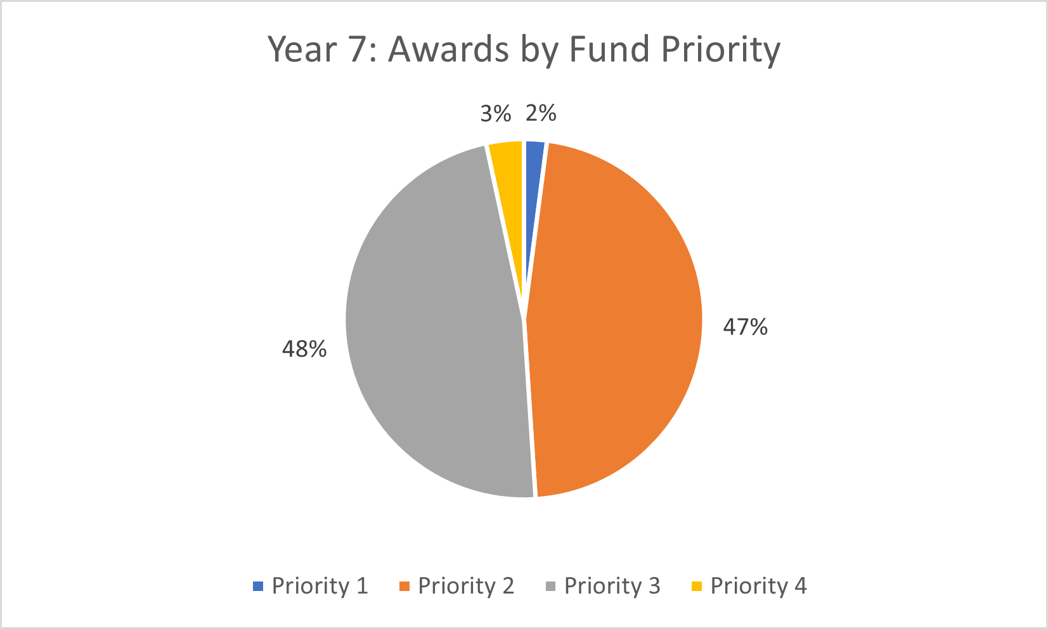

There was a continued increase in bursary awards made in the Fund’s high Priority areas in 2023 with 49% relating to Priority One (renewables) and Priority Two (engineering, construction, STEMD) compared to 42% in the previous year.

Geographical spread was similar to the previous year with 57% of awards by value made to residents in Lochbroom and minor changes in other areas.

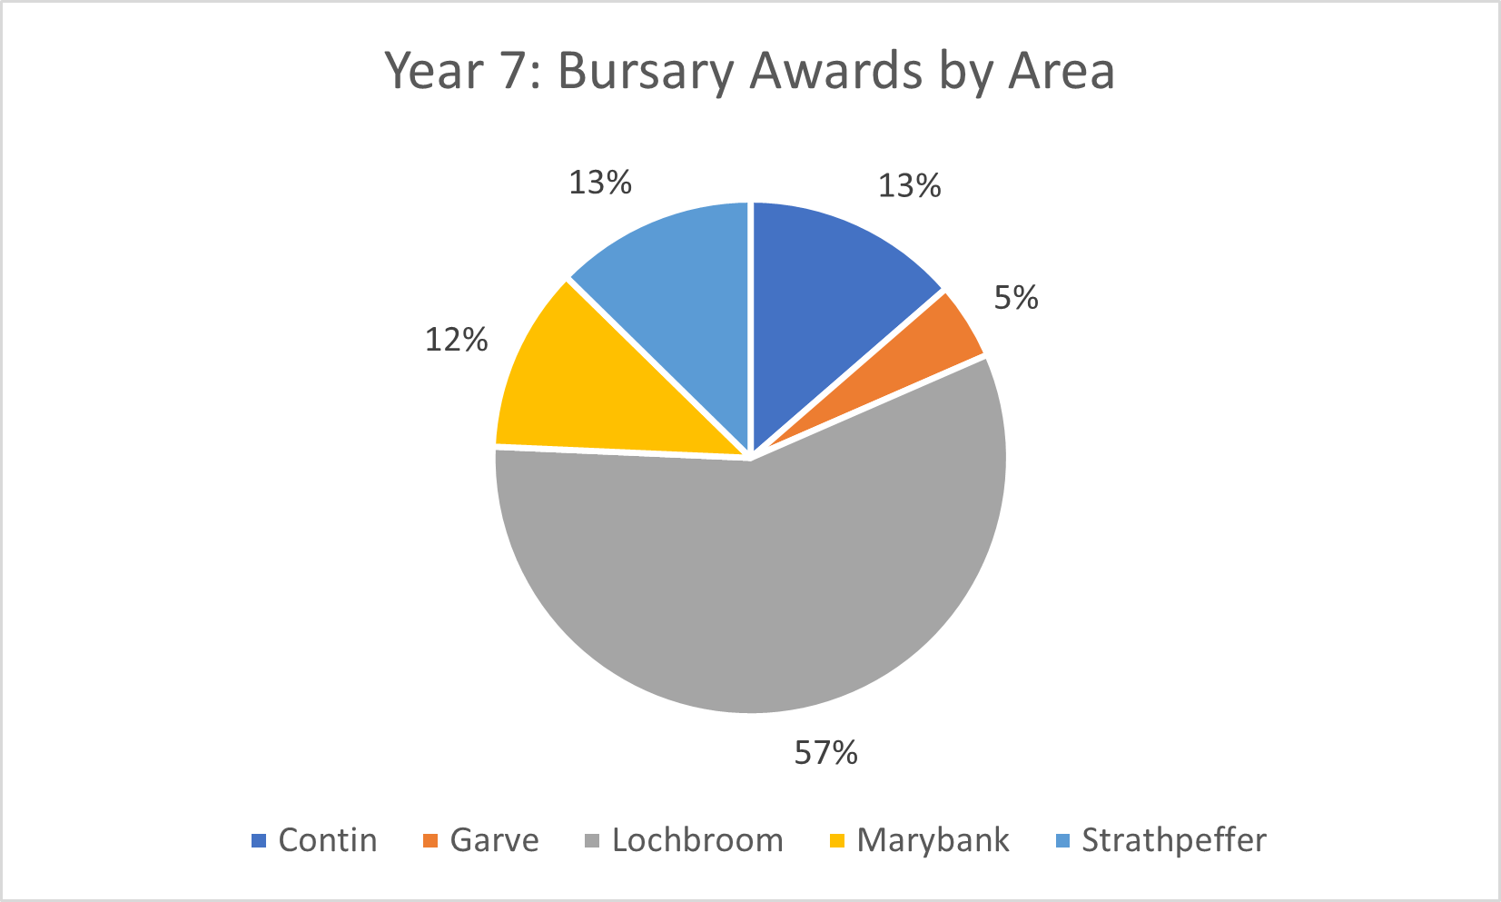

Ten bursary applications were withdrawn prior to assessment due to ineligibility of some of the requested expenditure or issues with retrospective funding. No applications which met the criteria were rejected by the Panel. This gives a conversion rate of applications to awards of 85%.

  - Panel
The EDF Renewables Corriemoillie Education and Training Fund Panel makes decisions on how the Fund is spent and helps promotes the Fund locally. It also advises on overall fund strategy. The Panel comprises one community member from each of the five community council areas, plus representatives from business and skills/training agencies.
The Panel met three times during the year to consider applications to the Fund, in March, August and December, holding meetings online in all cases. The decision has been taken to hold all meetings on line for this group, which has a wide geographic spread, and is very comfortable continuing with the virtual meeting arrangements.

Panel members at 15 December 2023 were:

Community/ Sector | Panel Representative
Contin | Christopher Buxton
Garve & District | Sue Tarr
Lochbroom/Youth representative | Jack Allan-Sangster
Marybank, Scatwell & Strathconon | Christine Mackintosh
Strathpeffer | Lynne Reid
Industry/Business | Sheree Grant (local business representative)
Skills/Training Agencies | Roddy Bailey (Skills Development Scotland)

1.4 Finance

Statement Period: 16 December 2022 to 15 December 2023

Balance brought forward | £39,090.66
Income
EDF Renewables | £58,856.78
Interest | £0.07
Expenditure
Grants awarded - paid | £55,883.40
Grants awarded - pending | £31,856.00
Fund expenses | £0.00
Grants returned/cancelled | -£8,048.00
Balance carried forward | £18,256.11

EDF Renewables Corriemoillie Wind Farm Community Benefit Fund - Contin

The Contin Community Fund continues to support a diverse range of projects, supporting groups in the village and also looking outwith the area to contribute to projects in neighbouring communities which will directly benefit local residents.

Local priorities for the fund, based on community consultation, include access; heritage; youth activities; play park for younger kids; community garden; social events and activities for families and other residents. The maximum award is £3,000.

The following case studies illustrate this range of activity which allows local initiatives to develop and also supports collaboration with neighbouring communities on shared issues such as transport.

Case Studies

Community Archaeology in Contin

Contin’s Hidden History is a project led by Contin Community Council that aims to explore the early settlement of Contin, Ross-shire, and its church, which was founded by St Maelrubha in the 8th century AD.

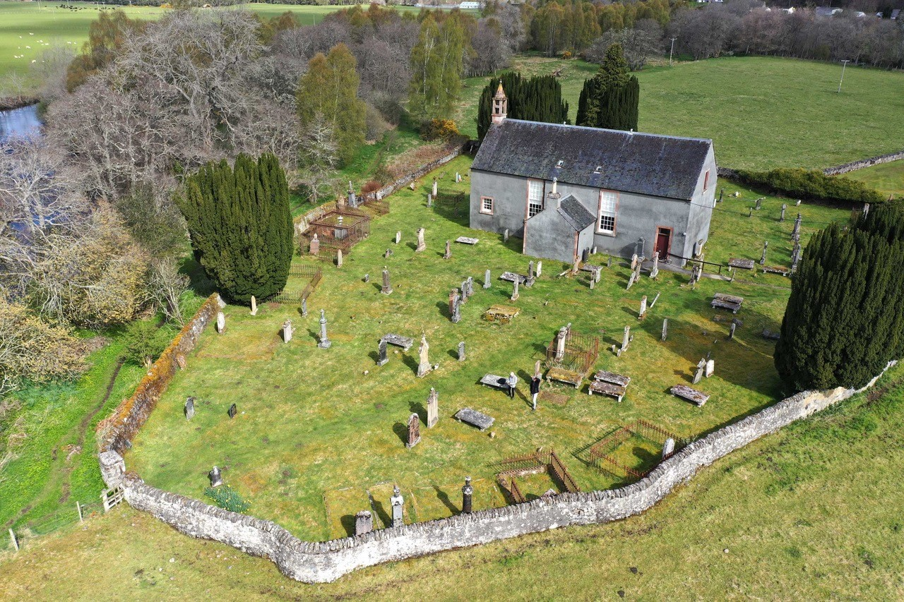
Contin Church (copyright Andy Hickie)

In late 2020, Contin Community Council received an award from this fund of £2,744 to research and survey historical sites around

Contin to determine the significance of the local history and to then promote the findings.

There were various delays to the project in the initial stages, mostly due to pandemic related restrictions. This meant that not all planned activity took place and there was an underspend on the project. However other opportunities arose in this period, particularly building a link with the Orkney Research Centre for Archaeology (ORCA) which is part of UHI.

The ORCA team bring significant technical expertise as well as considerable experience of community engagement, both in training volunteers and sharing the survey results. This new partnership led to a rethink on the project plan and a bid for some additional funding to cover the cost of the professional input.

The funding request in 2023 was for a further £2,750 to add to the underspend of £2,400 from the 2020 award to contribute to the overall project cost of £10,103, with match funding from Historic Environment Scotland (HES). These costs are mostly based on professional staff time to carry out the technical survey work and to deliver the community outreach aspects, along with associated expenses. There has been considerable in kind input from local volunteers in managing and delivering the project, and developing it in the longer term.

The new project aimed to investigate the fields around Contin church for evidence of medieval/pre-medieval structures, using specialist survey equipment. Local people were involved at all stages, and had opportunities to learn archaeological methods and techniques. Four local residents were trained and took part in the survey work.

In addition, 50 pupils from Strathpeffer primary School visited the team during the survey. Pupils had a try with the magnetometer and helped collect data with the earth resistance instrument. A follow up workshop was held at the primary school with the same pupils, delivered by ORCA staff.

A public talk was held at Contin Community Hall (5th Dec) as part of the Highland Archaeology Festival. It was attended by 55 people and the results were met with interest. There was strong support for continued work on the island. A poster presentation about the project was presented at the Highland Archaeology Festival conference the weekend after the talk.

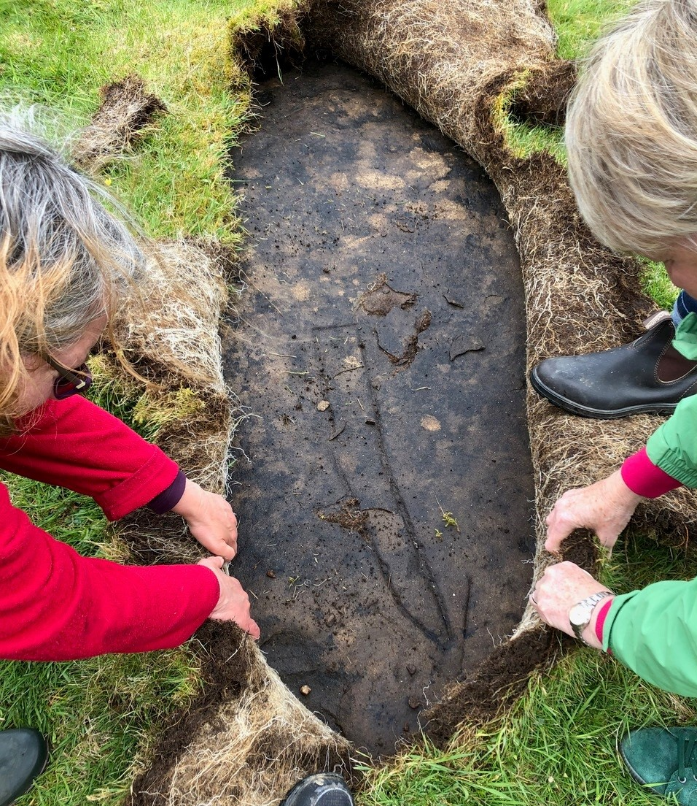
Hidden history unearthed!

The survey work provided a picture of activity across Contin island. Although no evidence was found for an extensive medieval settlement, there is the possbility that structures to the south of the church could be significant and according to ORCA and HES, this merits further research, which will be the focus of the next stage of the project.

Volunteer Phil Baarda said: “This project ran very smoothly with no issues or concerns. We planned the work closely with Orca and Strathpeffer Primary school - we found that thorough planning according to a realistic timetable paid off. Without EDF funding we would not have been able to run the project - it was a great boost to us, and we’re very grateful, especially as we’re now looking towards a phase II project based on the findings of this first one.”

Community Transport on the Move!

Contin and its neighbouring villages, Garve and Strathpeffer, have suffered badly in recent years from a reduced bus service. Without a car it is increasingly difficult to access work and leisure opportunities from the village, as well as getting to medical appointments or to the shops. For those with mobility issues, even accessing the bus stop can be a challenge.

Four years ago, Contin Community Council insitigated a Transport Feasibility study (supported by this fund) bringing neighbouring communities together to investigate options for a community led response to improve transport options. The pandemic of course delayed progress, but since then groups in Contin have been working closely with Garve and District Development Company in particular, to take this forward, combining resources to find a solution which will benefit the wider area.

GDDC was the obvious organisation to deliver this next phase, to build on the work they were already doing around transport issues. They employed a project manager for transport and green energy who worked extensively on the business, social and practical case for a local bus service, building on the initial feasibility research. Commitment was secured from Highland Council to either supply a bus from existing fleet for community use, or provide funds to purchase a bus. Contin Community Council applied on their behalf for £3,000 from this fund to contribute to total project cost of £18,255 for GDDC to then employ a part time project manager for one year, with a specific aim of setting up a transport service for the area.

The one-year development phase is ongoing (around halfway at the time of writing), with the project on track to be up and motoring by the summer of this year. Highland Council will provide an 8-seater diesel vehicle for the group and is committed to also supporting running costs (though not fuel costs) for three years. There is negotiation on going about taking on some local council service routes which would give the project some guaranteed income with the bus then available for on demand requests outwith any scheduled times. The aim is to employ two local part time drivers and also to train a small group of volunteers. The project manager is fundraising for running costs for the first three years to establish the service. A booking app would be used along side a project officer to handle admin and manual bookings where necessary.

Ultimately the hope would be to have an electric bus for the project.

Funding applications are also in place for EV charging infrastructure for the area at Aultguish and at Contin Hall – as fast charging infrastructure would need to be in place to make an electric bus a viable option in future.

The group has received considerable support from Highland Council who have been backing the project from the outset. They also have had help from the Community Transport Association particularly on many of the legal and technical issues around licensing, training, insurance etc. Other community transport projects in the area, such as the groups in Gairloch, Applecross and Nairn have also been very helpful with practical advice and information.

Project manager Ewan Bush said: “The Contin community has contributed in more ways than just helping to fund this project. Involved in the steering group, they have brought useful contacts and learning. Working on the project has highlighted the importance of good transport infrastructure and the wider impact it can have in the community – helping elderly residents live well for longer in their own homes and making the area more appealing and liveable for families and young people. Rural transport services have been eroding gradually over many years and it is good to see that there is now more recognition of the importance of good transport links and the wider benefits they bring, as seen by the commitment from Highland Council to support the project.”

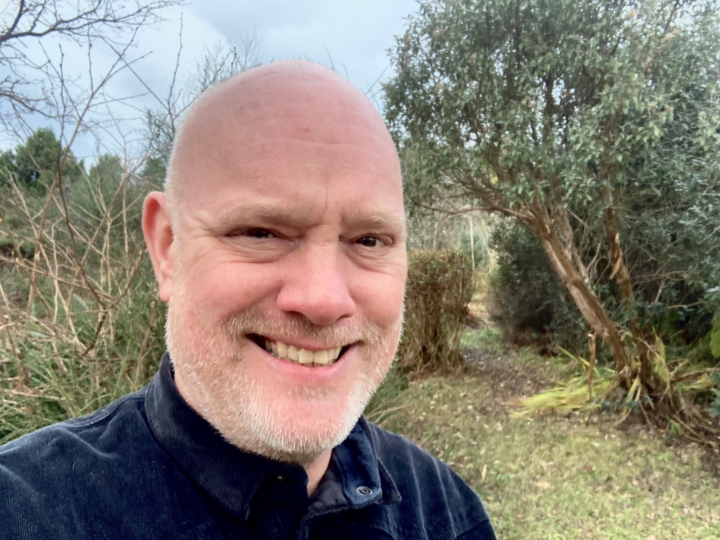
Ewan Bush

Norma Ross, Chair Contin Community Council said: “I feel this project has the capacity to improve the independence and therefore the well being of many of our residents whilst reducing our carbon footprint.”

2.1 Awards

Eight awards were made during the year, to a total value of £14,480. These are shown in the table below. This brought the total number of awards made over the six years to 37 and £70,927 in value. The award value represents 88% of the EDF donation for the year.

Organisation | Offer Statement | Project Cost | Award
Contin Baby and Toddler Group | To fund hall hire, equipment and first aid training to support play group activity for a year. | £1,386.40 | £1,386.40
Contin Community Council (Contin's Origins) | To commission archaeological surveys of Contin Island and work with local volunteers to assess and share the importance of Contin's origins. | £10,103.00 | £2,750.00
Contin Community Council | To fund a bi-monthly newsletter to keep the community informed and connected. | £2,142.00 | £2,142.00
Contin Community Trust | To purchase a hearing loop system, banner and event equipment to improve user experience and maximise use of the community hall. | £2,602.50 | £2,602.50
Contin SWI | To contribute to cost of annual members' outing. | £1,500.00 | £1,000.00
Fox & Friends | To deliver interactive story and activity sessions for pre-school children to improve literacy, parenting and bring families together. | £4,339.00 | £600.00
Garve and District Development Company | To contribute to project manager costs to set up a demand response transport service to improve local transport options. | £18,500.00 | £3,000.00
Strathpeffer Residents' Association | To contribute to the cost of installing playpark equipment in Strathpeffer Community Park. | £1,000.00 | £1,000.00

One application was deferred for further information by the Panel during year seven, so the conversion rate from application to award was 89%. The deferred application will be reconsidered in 2024 if further information is supplied.

  - Financial Statement

Statement Period: 16 December 2022 to 15 December 2023

Balance brought forward | £33,824.14
Income
EDF Renewables | £16,486.27
Expenditure
Grants awarded - paid | £20,816.46
Grants awarded - pending | £0.00
Fund expenses | £15.00
Grants returned/cancelled | £0.00
Balance carried forward | £29,478.95

2.3 Governance

The EDF Renewables Corriemoillie Contin Community Fund Panel makes decisions on how the Fund is spent and helps promote the Fund locally. The Panel can comprise one nominee of Contin Community Council and up to six other representatives from the community.

Panel membership was consistent throughout the year. The panel met twice
during the year, once by zoom and then in-person at the new Contin hall. The panel hopes to continue meeting in person going forward, to support and take advantage of the new hall.

Panel members at 15 December 2023 were:

Lisa Miller
Fiona Penfold
Selina Rennie
Norma Ross
Vicki Ross
Bill Wood
Phil Baarda/Sherry Morris*

*share the role

3. EDF Renewables Corriemoillie Wind Farm Community Benefit Fund - Strathpeffer

The Corriemoillie Strathpeffer Community Fund continues to be well subscribed in a small community which boasts a significant number of community owned assets – including the community centre, community park, footpath initiatives and the iconic Pavilion – as well as a number of clubs for golf, bowling and other activities.

Funding has proved useful to several of these groups to help lever in much larger sums from other sources for larger capital works, as well providing crucial support for equipment and other locally identified needs.
The following case studies give a flavour of some of the ambitious projects currently underway in the village – bike tracks and a new community shop – and show how relatively small amounts of funding can make a big difference.

Projects supported should relate to the Community Action Plan and demonstrate local benefit. The maximum award is £3,000.

Case Studies
Weighing in on a new community service!

Strathpeffer Community Development Trust (SCDT) runs a number of local events and intiatives including operating the Community Centre, and recently establishing a community shop.

Strathpeffer Station Trading officially launched September 2023, in a unit which is leased from Old Strathpeffer Railway Trust.

SCDT first researched the viability of taking on the former fairtrade shop as a community enterprise, to sell products and provide services (such as refill stations and sale of second hand goods) that are not otherwise available locally and that support sustainable and environmentally friendly lifestyles. They received a lot of positive community feedback and developed a business case so the project was approved at the SCDT AGM.

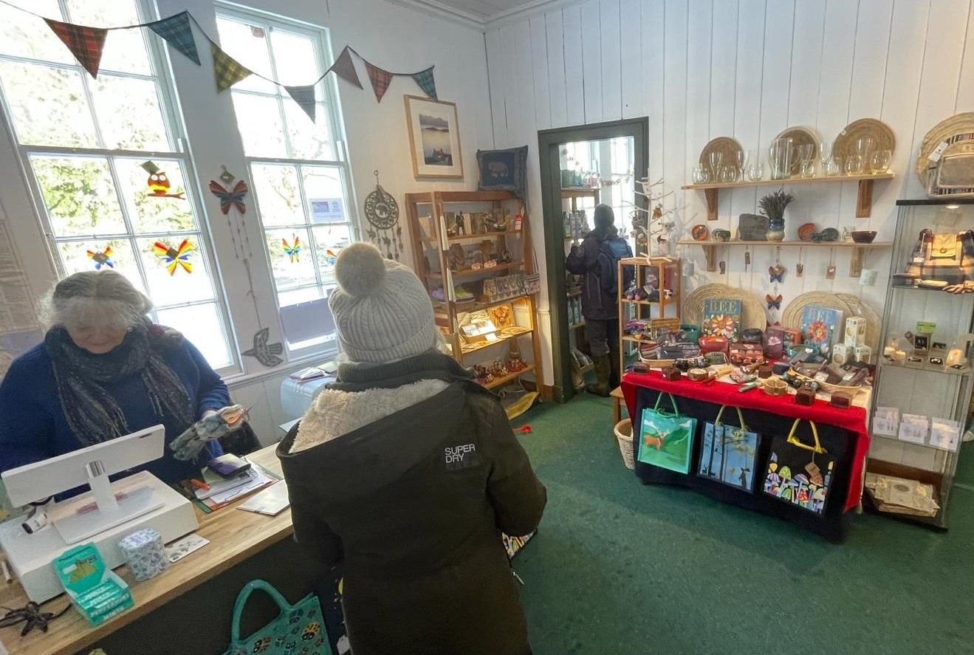

SCDT has set up a separate steering group for the shop which is staffed by a mix of part time staff and volunteers. The shop sells a range of locally and ethically produced crafts as well as selling refill products such as washing liquid and detergent.

In order to offer a wider range of refill goods (particularly dried goods sold by weight in customers own container), SCDT applied for funding to purchase some specialist equipment to display, store, dispense, weigh and ticket goods for sale. The refill aspect is seen as a key service particularly to local people who will provide the majority of shop footfall outwith the tourist season.

SCDT was awarded £3,000 in November 2023 to purchase the necessary equipment to set up the refill station. Further research led to a modification of their plans however, in terms of the most useful equipment to meet their needs. Volunteers aranged a visit to a similar project in the area – Ullapool Unpacked – which they found to be very useful. The Ullapool experience suggested that a better system would be having staff weigh and measure the goods, rather than letting customers do this themselves. They still needed to purchase calibrated scales, but could opt for a much simpler and therefore cheaper version.

Further advice from environmental health also impacted plans and was all part of the steep learning curve for the volunteers involved. As the refill station involves open food (as opposed to sealed and packaged food - which is the point of it!) there were further requirements to be met in order to be fully compliant. Shop staff and volunteers require food handling training, the racking needs to be wipable and there is a need to install a hand sink and water heater in the shop/storage area.

This all led to a rebalancing of the budget but the team are confident they will now have the right set up in place to make this part of the initiative a real success.

SCDT and shop volunteer, Miranda Wharam, said:

“The shop is doing really well - household refills are already very popular – and we are still confident that the dry foods will be successful as refill option.

We have lots of ideas to add further value, such as working with local food producers. We will be collaborating with a local artisan breadmaker for example. They have been invited to do a tasting session in Real Bread Week, where bread flour will be on sale. We are planning a Christmas Fair and working with the local primary school on waste issues. So many possibilities from this exciting new project!”

Cycle Zone Progress

Highland Trail Riders (HTR) is a constituted sports club which builds and maintains bike trails, mainly in the forestry around Contin and Strathpeffer. HTR is working with Strathpeffer Community Park to develop cycle tracks and create an exciting Cycle Zone as part of the ambitious community park plans.

The Cycle Zone is being developed in phases. HTR volunteers initially developed a short cycle track with one jump as an introduction to trail riding for the youngest riders (balance bikes upwards). The next phase was then to add more interest and features by creating three "table top" jumps. HTR was awarded £2,000 to contribute to the total project costs of £4,000.

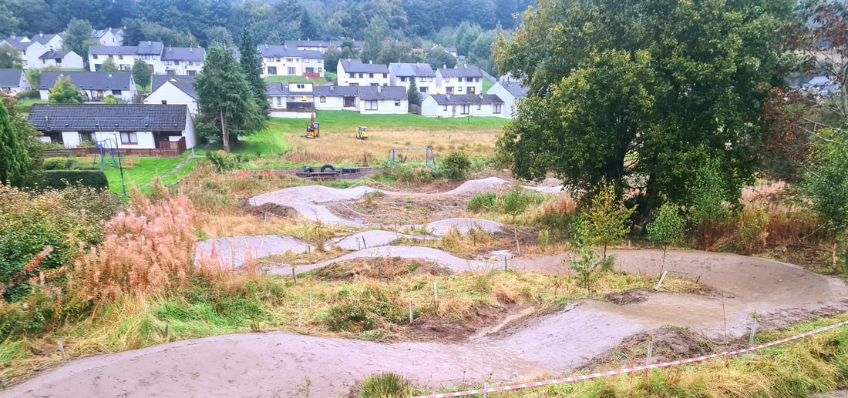
Strathpeffer Community Park Cycle Zone

Some issues arose around the construction due to bad weather which highlighted the need for more drainage on the site, as well as necessitating repair work to the initial cycle track. This was useful in highlighting the drainage requirements for the next phase of building the pump track. HTR also gained further experience around project planning and the need for flexibility and changes once construction is underway, based on actual site conditions.

This also had an impact on the budget and the volunteers are definitely gaining experience in fundraising and building relationships with funders where that is possible. They are also more aware of the importance of planning for the use of machinery in the design stage in order to maximise the use of expensive plant when available and minimise hire charges.

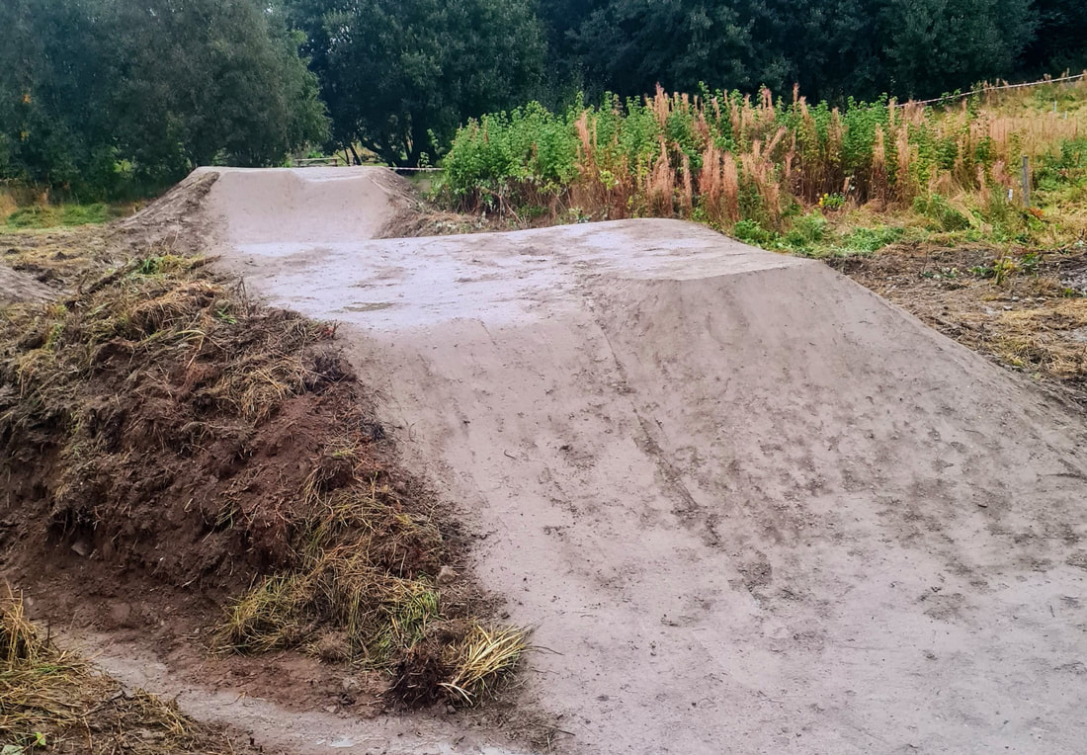
Jumps under construction

The project is a good example of successful partnership working. HTR bring technical expertise and a different group of volunteers to support the Residents Association who are managing the park project overall. There is also potential that they can access different funding streams though communication has been key as both groups may be approaching the same sources and there is a considerable amount of capital funding required to deliver the full community park vision.

Volunteer project lead, Graham MacDonald said: “The award from the Strathpeffer community fund was integral to prove to other funders that match funding was in place and really helped us lever in additional funds from elsewhere. We couldn’t be prouder of the track we have built so far and can’t wait to get it officially opened and in use in the spring!”
HTR is currently fundraising for the next phase which is to build a full pump track on the site, which will be a terrific asset for the local area and hopefully inspire lots of kids and families to get out on their bikes.

3.1 Awards

Nine awards were made during the year, to a total value of £15,528. These are summarised in the table below. This brought the total awarded over years one to six to £101,830, and the total number of awards to 52. There continues to be strong demand for funding from a range of local groups with award funds fully committed for the year. No awards were rejected in 2022 making an application conversion rate of 100%.

94% of the annual EDF donation was awarded in 2023. In total 98% of funds available have been distributed since the fund began.

Organisation | Offer Statement | Project Cost | Award
Highland and Islands Blood Bikes | To contribute to costs of transporting emergency medical supplies and samples to improve health outcomes for local residents. | £3,000.00 | £500.00
Highland Trail Riders | To create jumps on the beginner cycle trail to improve outdoor play facilities for children and young people. | £4,000.00 | £2,000.00
Strathpeffer & District Community Rowing Club | To purchase marker buoys and radios to help develop the youth membership and improve health and wellbeing of young people. | £990.00 | £990.00
Highland Trail Riders | To contribute to cost of creating a pump track in the community park Cycle Zone to encourage cycling and outdoor activity. | £25,000.00 | £2,000.00
Strathpeffer Community Development Trust (centre equipment) | To purchase essential electronic equipment, music licence and equipment and training for PAT testing to ensure safe and viable running of the community facility. | £2,225.00 | £2,225.00
Strathpeffer Community Development Trust | To purchase scales, dispensers and racking for the community shop to increase the range of refill products available to reduce waste and improve local retail opportunities. | £30,300.00 | £3,000.00
The Old Strathpeffer Railway Station Trust | To purchase one outdoor dual bin to encourage recycling and hand dryers to reduce paper towel waste to promote positive climate action. | £2,739.74 | £1,777.87
The Old Strathpeffer Railway Station Trust | To fund additional staff time for volunteer recruitment, development and support to ensure the long-term viability of the Museum of Childhood. | £2,215.50 | £2,035.50
Strathpeffer Community Council (Microgrant) | To provide a fund for distribution to groups and individuals for general charitable purposes in the form of micro-grants. | £1,000.00 | £1,000.00

3.2 Financial Statement

Statement Period: 16 December 2022 to 15 December 2023

Balance brought forward | £5,641.05
Income
EDF Renewables | £16,486.26
Expenditure
Grants awarded - paid | £20,028.37
Grants awarded - pending | £3,000.00
Fund expenses | £64.00
Grants returned/cancelled | -£3,000.00
Balance carried forward | £2,034.94

3.3 Governance

The Strathpeffer Panel, comprising the members of Strathpeffer Community Council, makes decisions on how the Fund is spent and helps promote the Fund locally. The panel met twice in 2023, and is back to in person meetings at the Community Centre with option of joining remotely available.

Panel members at 15 December 2023 were:

Peter MacLellan
Archie Macnab
Ron McAulay
Lorna Holland
Graham Reid
Marcus Thomson

EDF Renewables Corriemoillie Wind Farm Community Benefit Fund – Marybank, Scatwell & Strathconon

The Marybank, Scatwell & Strathconon Fund was launched in November 2019 and made its first awards in 2020.

The maximum award is £5,000.
The fund review in 2022 identified the cost-of-living crisis as a priority issue for the fund. The following case studies demonstrate two specific ways that local projects are tyring to help residents cope with the cost of living situation, as well as bringing wider benefits to local people

The Fund aims to support projects which will provide positive change and strategic impact. Projects must meet one of the following outcomes:

- enhance quality of life for local residents
- contribute to vibrant, healthy, successful and sustainable communities
- promote community spirit and encourage community activity.

Case Studies
Spreading Christmas Cheer!

Marybank, Scatwell and Strathconon Community Council received £3,300 in August 2023 to supply vouchers for groceries for 44 households to alleviate cost of living pressure and improve quality of life.

The cost-of-living crisis – identified as a fund priority in 2022 - continued to be a major issue for many households in 2023 with ongoing increases in costs of fuel, electricity and food. With another winter approaching, the community council was keen to do something to help, particularly the elderly and families with children, who would struggle to make ends meet.

The previous year, the community council had taken action to identify households with young and elderly members and had secured funds from the National Lottery, Scottish Government, Highland Council and Fairburn Estate to set up a voucher scheme.

This had been well received with positive feedback from local residents and so the community council was keen to build on this experience and provide help again.

In 2022 MSSCC identified 132 households in the area with at least one member over 65 years of age or at least one child under 16 years of age as well as a few residents who experience particular financial hardship, who do not fall into any of these categories but are known be reluctant to ask for help.

A similar number was identified in 2023, with community council members confirming they had been thorough in their research and had picked up any gaps from feedback the previous year.

With match funding confirmed from SSE Fairburn Wind Farm, the Corriemoillie award again made it possible to give each target household vouchers in the weeks before Christmas. Vouchers were supplied from a traditional butcher’s (£40 per household) and a greengrocer’s shop (£35 per household) in Dingwall, supporting local businesses, and were valid for a year. Community council members hand-delivered the vouchers to qualifying households in late November so they also had a chance to speak to most residents at the same time.

Christine Mackintosh, chair of the community council said: “Thanks to generous funding from the Windfarm Community Funds at Fairburn (SSE) and Corriemoillie (EDF, Foundation Scotland) Marybank, Scatwell & Strathconon Community Council were able to convey another round of food vouchers to residents in the run up to Christmas.

The aim was to help with the ever-rising cost of living and bring some light and warmth in the current climate of increasing negativity in so many areas. Recipients were highly delighted. MSS CC has received a number of emails, thank-you cards and positive comments on Facebook.

Mostly though, residents expressed their appreciation directly when they were handed the envelopes with the vouchers.”

Feedback from the community was overwhelmingly positive with dozens of messages of appreciation and thanks on the local facebook page.

“Brilliant idea and ideal that they are specifically for using in local shops. Many thanks.”

“Such a kind gesture and so appreciated.”

“Thank you everyone for all the hard work which went into delivering the vouchers. A wonderful help.”

“Thank you very much, it’s very much appreciated at this time of year.”

“Thank you for vouchers they will come in handy especially as I have big family.”

Supporting local families

Marybank Primary School Parent Council (MPSPC) is a proactive group, supporting pupils and staff through events, fundraising and other projects.

MPSPC was awarded £3,443.50 from this fund in 2022 to fund nature and heritage-based outings and outdoor activities for local children to create social opportunities and promote well-being post-covid. Their playpark improvement project was also supported by the Corriemoillie fund.

This project is to contribute to cost of all primary six and seven pupils at Marybank and Strathconon Primary Schools (14 pupils) to attend a five-day residential trip at Dalguise Centre in Perthshire in May 2024. The costs of £500 per pupil include transport, full board, and a wide range of adventure activities. Pupils from Strathgarve, Mulbuie and Ferintosh will also be on the trip, which will help all pupils make connections in their transition to secondary school. The aim is to develop new skills, confidence and self esteem and help the children forge new friendships.

Opportunities for residential trips were not available in recent years due to pandemic restrictions and the school is hoping to reinstate this as a regular experience for senior pupils. However there were concerns raised among local families about paying for the trip, which although good value, is unaffordable for some. There was feedback that some families would not be able to participate at all in which case it was agreed that there would be a collective effort to reduce or eliminate the financial costs for all families or to secure funding to subsidise as many places as possible.

Based on discussions with local families, a target of £120 was set for each child to contribute to the overall cost of the trip. The plan is to organise some activities as a group to help reach this target, recognising that in a small community, fundraising can be challenging. The children are committed to raising their own target amount, or certainly trying to, and appreciate being able to pull together and help each other to achieve this. The first event planned was a duck race and afternoon tea in late November which was a great success.

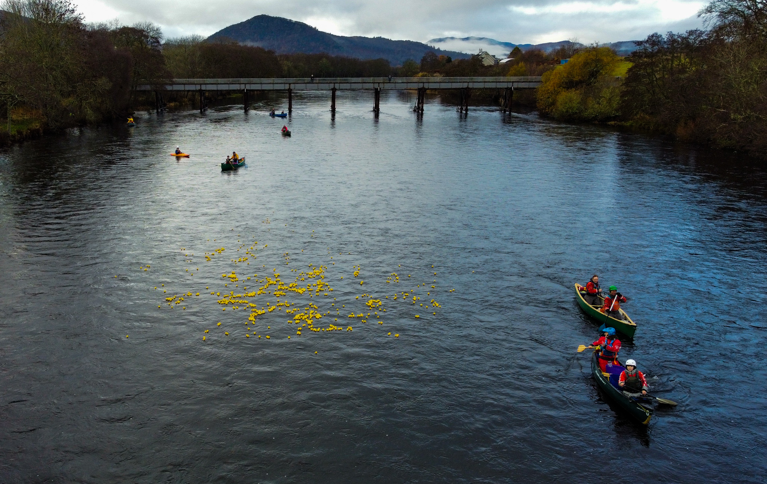
Keeping an eye on the ducks!

Support from the Corriemoillie fund meant that each family had a much smaller target to raise, while still giving the children the opportunity to contribute to their own fundraising efforts, and means that all the children will benefit.

Eleanor Macdonald said: “Children throughout Strathconon and Marybank area live in a remote and rural setting with few opportunities to come together with their peers. This funding enables them to prepare for transition to secondary school through outdoor learning. They will do this with others and enjoy team building experiences that will build resilience. The impact on their lives is tremendous as they form new relationships with a wider range of young people and challenge themselves through the outdoor activities.”

4.1 Awards

Organisation | Offer Statement | Project Cost | Award
Fox & Friends | To deliver interactive story and activity sessions for children to improve literacy, parenting and bring families together. | £5,210.00 | £634.00
Scatwell Community Association | To purchase a potter’s wheel and kiln to deliver volunteer led pottery sessions for the community.* | £5,000.00 | £5,000.00
Scatwell Community Association | To fund a defibrillator. | £4,200.00 | £2,590.00
Strathconon Social and Recreational Society | To fund a defibrillator. | £4,200.00 | £2,590.00
Marybank, Scatwell and Strathconon Community Council | To supply vouchers for groceries for 44 households to alleviate cost of living pressure and improve quality of life. | £9,900.00 | £3,300.00
Marybank Primary School Parent Council | To contribute to cost of residential outdoor activity trip for all senior pupils at Marybank and Strathconon Primary Schools to develop new skills, confidence and connections between children from different areas. | £7,000.00 | £5,320.00

Six awards were made during the year, to total value of £19,434.

This represents 165% of the annual EDF donation, with awards made using some of the historic underspend the fund accumulated prior to launching in 2020.

This makes a total of 17 awards since the Fund launched, with a total value of £52,333.

Subsequently one of the awards was returned but this was still the biggest year for the fund, both in terms of number of awards and amount distributed.

One application was deferred for further information, but no applications were rejected outright, making a conversion rate of 100%.

*The award was returned due to key project volunteers leaving the area.

4.2 Financial Statement

Statement Period: 16 December 2022 to 15 December 2023

Balances brought forward | £28,477.80
Income
EDF Renewables | £11,771.36
Expenditure
Grants awarded - paid | £20,611.00
Grants awarded - pending | £0.00
Fund expenses | £15.00
Grants returned/cancelled | £5,000.00
Balance carried forward | £24,623.16

4.3 Governance

The EDF Renewables Corriemoillie Marybank, Scatwell & Strathconon Community Fund Panel makes decisions on how the Fund is spent and helps promote the Fund locally.

Panel membership is comprised of two members of Marybank, Scatwell & Strathconon Community Council, with the remainder recruited from the wider community. Panel meetings have reverted to being in person at Fairburn Hall with the option of video conferencing also available.

Panel members at 15 December 2023 were:

Christine MacKintosh
Nick Murray
Cormac Seekings
Malcolm Sutherland
Eleanor MacDonald
Fiona Martland
Sarah Marshall

EDF Renewables Corriemoillie Wind Farm Community Benefit Fund - Lochbroom

5.1 Governance

The Lochbroom Fund is normally administered as a micro-grant scheme by Lochbroom Community Council, with Foundation Scotland providing a single award to the Community Council in each year, for it to then disburse as small charitable grants of up to £250 to individuals and to groups.

  - Financial Statement

Balances brought forward | £0.00
Income
EDF Renewables | £2,352.15
Expenditure
Grants awarded - paid | £2,352.15
Grants awarded - pending | £0.00
Fund expenses | £0.00
Grants returned/cancelled | £0.00
Balance carried forward | £0.00

For more information contact:

Foundation Scotland

Marion McDonald
Community Fund Adviser
Tel: 07912 759524
Email: marion@foundationscotland.org.uk

Appendix 1 - Education & Training Fund Award Summary
Bursary Awards:

Reference | Priority | Offer Statement | Award | Area
FR-0069210 | 1 | To cover fees and contribute to accommodation costs relating to IWCF Well Control Level 3/4 (Driller/Supervisor). | £1,000.00 | Contin
FR-0068980 | 2 | To contribute to costs relating to BSc Environmental Geography | £1,500.00 | Contin
FR-0068984 | 2 | To contribute to costs of accommodation and subsistence relating to BEng Electronic and Electrical Engineering. | £1,500.00 | Lochbroom
FR-0069003 | 2 | To contribute to costs related to MChem Chemistry. | £1,500.00 | Marybank, Scatwell & Strathconon
FR-0069049 | 2 | To help fund tools and travel to college relating to Electrician Modern Apprenticeship - year 2 award | £1,000.00 | Marybank, Scatwell & Strathconon
FR-0069241 | 2 | To fund travel costs and equipment relating to HNC Electrical Engineering. | £251.20 | Marybank, Scatwell & Strathconon
FR-0068744 | 2 | To contribute to costs of accommodation, subsistence and equipment relating to MEng Naval Architecture with Ocean Engineering (year 2) | £1,000.00 | Lochbroom
FR-0069113 | 2 | To contribute to costs related to BSc Paramedic Science | £1,500.00 | Lochbroom
FR-0071963 | 2 | To contribute to costs of accommodation, subsistence and equipment relating to BSc Animal Biology | £1,500.00 | Contin
FR-0072050 | 2 | To contribute to costs of accommodation and subsistence relating to BSc Policing and Criminology (year 2 award) | £1,000.00 | Marybank, Scatwell & Strathconon
FR-0072099 | 2 | To contribute to costs of equipment and accommodation relating to BEng (Hons) Mechanical Engineering (year 2). | £1,000.00 | Strathpeffer
FR-0072183 | 2 | To purchase a laptop and contribute towards accommodation and daily living costs relating to BSc Mathematics & Statistics. | £1,500.00 | Lochbroom
FR-0073064 | 2 | To contribute to costs related to BSc Speech and Language Pathology | £1,500.00 | Strathpeffer
FR-0073312 | 2 | To contribute to costs related to MSci Veterinary Biosciences (year 2 award) | £1,000.00 | Lochbroom
FR-0073817 | 2 | To contribute to costs relating to BSc Applied Psychology | £1,500.00 | Lochbroom
FR-0074597 | 2 | To contribute to costs relating to MEng Civil Engineering (year 3 award) | £300.00 | Lochbroom
FR-0075035 | 2 | To provide funding for equipment, travel and subsistence relating to bricklayer apprenticeship. | £1,374.00 | Lochbroom
FR-0075073 | 2 | To contribute to costs related to HND Computing (year 2 award). | £1,000.00 | Strathpeffer
FR-0075086 | 2 | To contribute to course fees for distance learning HND in Mechanical Engineering. | £1,000.00 | Lochbroom
FR-0075650 | 2 | To contribute to travel costs related to SCQF Level 4 Performing Engineering Operations (Fabrication & Welding) | £1,000.00 | Garve
FR-0075772 | 2 | To contribute to costs of accommodation and subsistence relating to BSc (Hons) Sport and Exercise Science (year 2 award) | £1,000.00 | Lochbroom
FR-0068562 | 3 | To contribute to costs related to BA(Hons) International Business Management | £1,000.00 | Lochbroom
FR-0068974 | 3 | To contribute to costs relating to BSc Nursing (Children and Young People) - year 2 award. | £1,275.20 | Lochbroom
FR-0069217 | 3 | To fund fees for Chainsaw Maintenance, Cross-cutting and Felling training course. | £700.00 | Lochbroom
FR-0069246 | 3 | To contribute to costs related to studying BA (Hons) in International Business. | £600.00 | Lochbroom
FR-0069403 | 3 | To contribute to costs of driving lessons and travel expenses relating to HNC Acting and Performance. | £1,000.00 | Contin
FR-0069966 | 3 | To pay fees for SVQ3 Health and Social Care training | £1,200.00 | Marybank, Scatwell & Strathconon
FR-0070182 | 3 | To contribute to living costs relating to BA in Social Work | £1,500.00 | Lochbroom
FR-0070183 | 3 | To contribute to living costs relating to BA (Hons) International Tourism and Events Management degree (year 2 award) | £600.00 | Lochbroom
FR-0070461 | 3 | To contribute to living costs while studying an HNC in Animal Care (year 2 award) | £600.00 | Lochbroom
FR-0070541 | 3 | To contribute to living costs while studying a MA in Spanish/Italian | £1,000.00 | Lochbroom
FR-0070784 | 3 | To contribute towards equipment costs relating to HND Animal Care (year 3 award) | £200.00 | Lochbroom
FR-0070824 | 3 | To contribute to living costs while studying an HND in Sound Production | £1,000.00 | Lochbroom
FR-0071353 | 3 | To contribute to equipment, travel and subsistence relating to NC Music. | £1,000.00 | Strathpeffer
FR-0071535 | 3 | To contribute to costs relating to BA (Hons) Business Analysis and Technology & Finance | £600.00 | Lochbroom
FR-0071540 | 3 | To contribute to accommodation, subsistence and equipment relating to BA Media and Communications | £1,000.00 | Contin
FR-0071900 | 3 | To fund course fees for an accredited teacher training course in menopause yoga. | £480.00 | Marybank, Scatwell & Strathconon
FR-0072085 | 3 | To contribute to costs of fuel and travel relating to MA Arabic and Spanish. | £1,000.00 | Strathpeffer
FR-0072115 | 3 | To fund fees for Introduction to commercial fishing course - health and safety and first aid | £320.00 | Lochbroom
FR-0072266 | 3 | To contribute to costs of accommodation and subsistence relating to BA (Hons) Accountancy (year 2) | £600.00 | Lochbroom
FR-0072306 | 3 | To contribute to costs relating to BA (Hons) Art and Design (year 2 award) | £600.00 | Lochbroom
FR-0072843 | 3 | To contribute to costs relating to BA (Hons) Film (year 3 award) | £200.00 | Lochbroom
FR-0073017 | 3 | To contribute to costs related to BMus Music degree. | £1,000.00 | Lochbroom
FR-0073094 | 3 | To contribute to costs of travel and equipment relating to NC Art and Design. | £1,000.00 | Strathpeffer
FR-0073831 | 3 | To contribute to costs relating to BA (Hons) Financial Services (year 2 award). | £600.00 | Lochbroom
FR-0074440 | 3 | To contribute to costs relating to MA (Hons) in Primary Education with Gaelic | £1,000.00 | Lochbroom
FR-0074761 | 3 | To contribute to costs relating to BA (Hons) Child and Youth Studies | £500.00 | Lochbroom
FR-0075362 | 3 | To contribute to cost of course fees for BSc Professional Practice Paramedic Science. | £1,324.00 | Lochbroom
FR-0075727 | 3 | To fund fees for Paddlesports Touring Leader Award. | £200.00 | Marybank, Scatwell & Strathconon
FR-0075846 | 3 | To contribute to travel and subsistence costs relating to Professional Cookery SCQF Level 5 | £830.00 | Garve
FR-0076799 | 3 | To cover the costs of course fees for the Introduction to Somatic Experiencing online training. | £350.00 | Marybank, Scatwell & Strathconon
FR-0072201 | 4 | To contribute to travel costs relating to BA (Hons) History and Politics (year 3 award) | £150.00 | Garve
FR-0070460 | 4 | To contribute to cost of driving lessons to access work and training. | £500.00 | Garve
FR-0071306 | 4 | To contribute to cost of driving lessons. | £500.00 | Contin
FR-0074645 | 4 | To contribute to cost of driving lessons to improve access to training and employment. | £500.00 | Contin

Support for Business & Organisations

Reference | Priority | Offer Statement | Award | Awardee
FR-0075117 | 1 | To fund training and accreditation in air source heat pump renewable heating installation to develop a local business and improve local services. | £2,500.00 | Napier Engineering Ltd

Appendix 2 - Background to the Fund

EDF Renewables Corriemoillie Wind Farm Community Benefit Fund is a charitable fund established to benefit people living in the community council areas of Contin; Garve & District; Lochbroom; Marybank, Scatwell and Strathconon; and Strathpeffer (the Area of Benefit). This report covers the operation of the Fund from 16 December 2022 to 15 December 2023, its seventh year of operation.

The Fund is linked to EDF Renewables’ Corriemoillie Wind Farm in Ross-Shire and annual donations equate to £5,000 per MW of installed capacity at the Wind Farm per year. Donations to the Fund rise annually in accordance with the Consumer Price Index. Based on the wind farm export capacity of 48.45MW, the funding totalled £242,250 in the first year of operation (2016 - 2017) and has risen to £266,886 in Year 6. The funding is expected to continue for the operating lifetime of the wind farm, which is likely to be 25 years.

The Fund is split into six sub-funds. Each community council area has its own local community fund and there is an Education and Training Fund covering all five community council areas. The Education and Training Fund accounts for 20% of the overall funding with the remaining 80% split across the five
communities as follows:

Community council area | Proportion of remaining funds
Contin | 7%
Garve & District | 80%
Lochbroom | 1%
Marybank, Scatwell & Strathconon | 5%
Strathpeffer | 7%

This report covers those sub-funds held and administered by Foundation Scotland and therefore not the Garve & District sub-fund, which is administered by the Lochluichart Community Trust.

The report firstly sets out an overall financial summary, then provides details for each sub-fund as follows:

- The sub-fund priorities for grant-making
- Applications received and awards made during the year
- A financial statement
- The difference the Fund is making
- Key issues and challenges for the sub-fund going forward
- Governance arrangements
- Marketing and communications activity

Appendix 3 – Education & Training Fund Framework

The Fund was established to support a range of specific outcomes:

- More individuals resident within the Area of Benefit are equipped with the range of skills and confidence required to enter into and retain employment in the key sectors the Fund supports;
- Micro (1-10 employees) / small (11-50 employees) businesses are able to create new job opportunities or retain existing jobs that may benefit individuals resident in the Area of Benefit;
- Micro / small businesses that employ individuals from the Area of Benefit have the necessary skills and confidence to grow and sustain their operations in order to secure their long-term future.

The Fund continued to focus on the following priority sectors in Year Seven:

Priority 1: Renewables and energy industry related

Priority 2: Engineering, construction and related trades, health & safety, and STEMD (Science, Technology, Engineering, Maths and Digital)

Priority 3: Industries which will benefit job retention in the area, including tourism, forestry and timber technologies, rural development, agriculture (including crofting, environmental conservation; estates management; aquaculture/fisheries management,

equestrian, other land-based industries, food & drink, health and social care, creative industries, life sciences, finance and business services, haulage, education and other sectors generating benefits for the local community

Priority 4: Other education courses that enhance employability and the success of micro and small sized businesses, including ability to set up and grow your own business. Examples are: marketing & sales, IT & web development, managing staff, accounts / financial management, entrepreneurship and business sustainability

Awards were offered under three distinct strands:

Bursaries to support individual’s costs of attending training, education courses or apprenticeships with a maximum award level of £1,500 in year 1 of the course, £1,000 in year 2, and £300 each in years 3 and 4 for Priority 1 and 2 sectors, with decreasing amounts available for Priority 3 and 4.

Support to businesses of up to £2,500 per organisation per year for staff training and development leading to a recognised vocational qualification. Support of up to £3,000 for activities that enable individuals to develop their career aspirations and journey. This includes access to learning resources that support the development of career aspirations, learning and development that increases employability, and activities that inspire and motivate individuals by developing links with prospective employers.

Appendix 4 - Financial Statement

Statement Period: 16 December 2022 to 15 December 2023

 | Education  & Training | Contin | Marybank, Scatwell & Strathconon | Strathpeffer | Loch-broom | Total
Balances brought forward | £39,090.66 | £33,824.14 | £28,477.80 | £5,641.05 | £0.00 | £107,033.65
Income
EDF Renewables | £58,856.78 | £16,486.27 | £11,771.36 | £16,486.26 | £2,352.15 | £105,952.82
Expenditure
Grants awarded - paid | £55,883.40 | £20,816.46 | £20,611.00 | £20,028.37 | £2,352.15 | £119,691.38
Grants awarded - pending | £31,856.00 | £0.00 | £0.00 | £3,000.00 | £0.00 | £34,856.00
Fund expenses | £0.00 | £15.00 | £15.00 | £64.00 | £0.00 | £94.00
Grants returned/cancelled | -£8,048.00 | £0.00 | -£5,000.00 | -£3,000.00 | £0.00 | -£16,048.00
Balances carried forward | £18,256.11 | £29,478.95 | £24,623.16 | £2,034.94 | £0.00 | £74,393.09

Appendix 5 – Fund Promotion

Foundation Scotland, alongside the Fund Panels, sought to raise the profile of the Funds through a variety of channels during year seven, as set out in the table below.

Channel | Notes/Impact
Press | Corriemoillie wind farm fund operated by EDF Renewables generates boost for Ross-shire groups with refugee effort, rowers and path project all benefitting  Ross-shire Journal 20 Feb 2023  Corriemoillie wind farm cash powers new opportunities for locals with latest round of bursary awards through EDF Renewables  Ross-shire Journal 26 Jan 2023
Website | The Fund webpage saw 1,284 visits of which 603 were unique  Promotion on local websites.
Social Media | Promotion on Foundation Scotland (3,500 Facebook followers) and local social media sites.  130 followers on Corriemoillie Facebook account.
Direct Contact | E-mailings to local newsletters, schools, and other stakeholders to promote each funding round.  Summary of awards sent to Panel and Community Councils.
Posters | Via local notice boards at community venues, shops etc.
Enquiries received | Ad hoc queries from potential applicants, requests from the press and public for information, etc.
Publicity advice to awardees | “Acknowledging your grant” publicity advice sheet appended to grant offer letters (for non-bursary awards).

